**Hack Challenge 2021  
  
Super Predictor of Indian Premier League (IPL)**

**1. INTRODUCTION:**

* 1. **Overview:**

BCCI has been organizing the IPL T20 cricket tournament every year. The use of analytical methods in various aspects of cricket including results prediction and toss decision for winning is very important.There is a huge demand for the algorithm that best predicts the result of cricket because of its popularity and huge amount of money involved in the game. Thus the analysis of IPL results becomes more important. Prediction of outcome of a match and toss decision using dashboard , plots and predictive model(with in the error limits) based on Machine learning is an important aspect in cricket. Records of the past performance of players,wininng, venue,etc and other related data can be analysed to create models that predicts the winning team. This model is created using IBM Cognos Analytics,IBM Watson Studio,NoDe Red,IBM Cloud their results can be compared based on the Evaluation Measures as accuracy, precision, recall, sensitivity and error rate.

**1.2 Purpose:**

The objective of the solution is to create dashboard that visualizes IPL data for certain set of stated problems. It will also be able to predict the team who will win the next match based on input provided by user ( Climate Condition, toss result, field/batting selection etc) using Machine learning algorithm (classification- as output is categorical). For analysis of current data set dashboard will be used ( bar graph, scatter plot etc).

**2. Proposed Solution**

Proposed Model By collecting the previous season data of each player and team, we perform training on the data by developing data analyzation. The information makes use of to calculate points of each player and also calculate the overall strength of each team based on past performance. The output is displayed with the help of various types of graphs where user can predict the match result or take decision in selecting the players for a particular match.

|  |  |
| --- | --- |
|  |  |
|  |  |

**Theoretical Analysis**Software Used

1. IBM Cognos Analytics

2. IBM Cloud

**Flow Diagram**

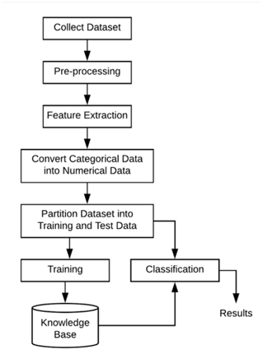

**Advantages**

* Predictive models help in predicting for future results.
* Easy analysis of large data set.
* Compatible model for future data as well.
* Graphical User Interface for better understanding.
* User friendly.
* Reduce Human effort for making conclusions.
* Can be developed/used by user with zero coding skill.

**Conclusion**

The IPL data analysis is the most famous technology in today’s world. With the help of the data analysis we can find out the pros and cons of the player and work on the performance of the individual player and also the whole, it will help in taking decision. The application can be used for the selection commission to select the best player including bowler, batsman and even the fielder for the team and to perform well on the field during match. It is helpful for all type of game to work on the performance and predict the future performance of the player and team. The following methodology helps in other T20 leagues around the world like PKL,LPL,CBL,BBL,SuperSmash,T20 Blast, MSL, BPL, APL, and World League CLT20.

**Future Scope**

The solution is not limited to current data set as prediction will be enhanced with more data entries in future. It will not only help in prediction of winning team but also will suggest whether the toss winner must go for fielding or batting based on past records. This will enhance gambling business in World by providing more accurate predictions. It can be made more accurate by integrating more data into it and using better designed algorithm.